Adjustment Microservice SOP

Production URL:
https://adjustment-microservice.prod.finance.ashleyfurniture.com/Adjustment/Orders
Stage URL:
https://adjustment-microservice.stage.finance.ashleyfurniture.com/Adjustment/Orders

The caller should call the microservice in a way that it responds with the value needed.
Example 1: if the caller needs the surcharge for the entire line-item quantity, then pass in the line-item quantity and the line item extended base price. The surcharge returned will be the extended surcharge for the quantity given.
Example 2: if the caller needs the surcharge for a single item (quantity 1) then pass in the quantity of 1 or no quantity and the base price for 1. The surcharge returned will be for a quantity of 1.

Input Field Definitions
- Order Level (one per order. May have multiple orders per call)
  - Order ID:
    - Entry: Optional
    - Format: String
  - Customer:
    - Entry: Required
    - Format: String
  - Ship To:
    - Entry: Required
      - Blank is a valid shipto
    - Format: String
  - Order Date:
    - Entry: Required
    - Format: ISO 8601
  - Estimated ship to:
    - Entry: Optional
    - Format: ISO 8601
  - Invoice Date:
    - Entry: Optional
    - Format: ISO 8601
  - Warehouse ID:
    - Entry: Optional
    - Format: String
- Item Level (one per item on this order. May have multiple items per order)
  - Item ID:
    - Entry: Required
    - Format: String
  - Quantity:
    - Entry: Optional
      - Quantity of 1 will be assumed if not provided
    - Format: Numeric
  - Price:
    - Entry: Required
      - Should be the total price for the quantity given
      - If no quantity is given, this should be the price for 1
      - No unit of measure necessary
    - Format: Numeric

Output Field Definitions
- Order Level (one per order submitted)
  - Order ID:
    - Return: Input value
      - If no field is passed then the return is blank
    - Format: String
  - Customer ID:
    - Return: Input value
    - Format: String
  - Ship To:
    - Return: Input value
    - Format: String
  - Total Surcharge:
    - Return: Sum of all surcharges for this order
    - Format: Numeric
- Adjustments Level (one per item submitted this order)
  - Item ID:
    - Return: Input
    - Format: String
  - Quantity:
    - Return: input
      - If no field is passed or if the value is passed as null then the return value is set to 1
    - Format: Numeric
  - Price:
    - Return: Input
    - Format: Numeric
  - Status:
    - Return: 0=API OFF, the API check switch is set to off
    - Return: 1=NONE APPLIED, no Adjustments applied for this item
    - Return: 2=APPLIED, Adjustments applied for this item
    - NOTE: If 0 or 1, no adjustment details will be sent for this item
    - Format: String
- Adjustment Details (can be multiple per item)
  - Credit Code
    - Return: Credit Code associate with the adjustment
    - Format: String
  - Adjustment Name:
    - Return: Name/Description of adjustment being applied.
      - Typically: credit code concatenated with its description
    - Format: String
  - Adjustment Amount:
    - Return: calculated dollar amount of this adjustment for the quantity given
    - Format: Numeric
  - Invoice level:
    - Return: 1= the adjustment should be applied on the line-item level
    - Return: 2= the adjustment should be applied on the Order level
    - Format: String (Character value for maximum flexibility)
  - Taxable:
    - Return: Y=yes; N=no
      - from the credit code
    - Format: String
  - Commissionable:
    - Return: B=INVOICE & CM; I=INV only; N=Neither
      - from the credit code
    - Format: String
  - Quantity:
    - Return: input
      - If no field is passed or if the value is passed as null then the return value is set to 1
    - Format: Numeric
  - Calculation value:
    - Return: number value used in calculation
      - example: 2 (indicating 2% when the calculation type is percentage)
    - Format: Numeric
  - Calculation type:
    - Return: type of calculation performed
      - example: “Percent”
    - Format: String
  - Applied level:
    - Return: attribute used to qualify for adjustment
      - example: “ItemClass”
    - Format: String
  - Applied Level value:
    - Return: attribute value
      - example: “ZABC”
    - Format: String
  - Charge:
    - Return: true or false
      - True = this is a charge that will increase the invoice amount
      - False = this is a credit that will decrease the invoice amount
    - Format: Boolean

JSON Definition

- Type of call – POST

- Swagger documentation(technical) for this microservice
https://aazeus-fnprwb01.ashleyfurniture.com/AdjustmentAPI/swagger/index.html

Example 1
Example of Input values for Microservice below. The minimum optional input values have been used. In this example the microservice check switch is set to ON

Input Values
{
"orders": [
{
"order_id": " ",
"customer_id": "8888300",
"ship_to": "480",
"order_date": "2024-06-27",
"est_ship_date": "",
"invoice_date": "",
"warehouse_id": "",
"items": [
{
"item_id": " ITEM-A",
"quantity": 1,
"price": 29.99​
},
}
]
},

Output values
{
"orders": [
{
"order_id": "ORD-001", (order passed in)
"customer_id": "8888300", (customer passed in)
"ship_to": "480", (ship to passed in)
"total_surcharge": 5,
"adjustments": [
{
"item_id": "ITEM-A", (item number passed in)
"quantity": 1,
"price": 29.99​
"status": “2”,
"adjustment_details": [
{
"credit_code": "IMP",
"adjustment_name": "IMP IMPORT SURCHARGE",
"adjustment_amount": 1,
"invoice_level": “1”,
"taxable": “N”,
"commissionable": “N”,
"calculation_value": 1,
"calculation_type": "PERCENT",
"applied_level": "ITEM CLASS",
"applied_level_value": "CLASS-A",
"charge": true
}
]
}
]
}
]
}

Example 2
Example of Input values for Microservice. The minimum optional input values have been used. In this example the microservice check switch is set to ON

Input Values
{
"orders": [
{
"order_id": "ORD-001",
"customer_id": "8888300",
"ship_to": "480",
"order_date": "2024-06-27T10:30:00Z",
"est_ship_date": "2024-06-30T14:00:00Z",
"invoice_date": "2024-06-28T09:00:00Z",
"warehouse_id": "005",
"items": [
{
"item_id": "ITEM-A",
"quantity": 1,
"price": 29.99​
},
{
"item_id": "ITEM-B",
"quantity": 2,
"price": 49.99​
}
]
},
{
"order_id": "ORD-002",
"customer_id": "8888300",
"ship_to": "480",
"order_date": "2024-06-27T11:45:00Z",
"est_ship_date": "2024-07-01T10:00:00Z",
"invoice_date": "2024-06-28T15:30:00Z",
"warehouse_id": "003",
"items": [
{
"item_id": "ITEM-C",
"quantity": 3,
"price": 19.99​
}
]
}
]
}

Output values
{
"orders": [
{
"order_id": "ORD-001",
"customer_id": "8888300",
"ship_to": "480",
"total_surcharge": 5,
"adjustments": [
{
"item_id": "ITEM-A",
"quantity": 1,
"price": 29.99​
"status": “2”,
"adjustment_details": [
{
"credit_code": "IMP",
"adjustment_name": "IMP IMPORT SURCHARGE",
"adjustment_amount": 1,
"invoice_level": “1”,
"taxable": “N”,
"commissionable": “N”,
"calculation_value": 1,
"calculation_type": "PERCENT",
"applied_level": "ITEM CLASS",
"applied_level_value": "CLASS-A",
"charge": true
}
{
"item_id": "ITEM-B",
"quantity": 2,
"price": 49.99​
"status": “2”,
"adjustment_details": [
{
"credit_code": "IMP",
"adjustment_name": "IMP IMPORT SURCHARGE",
"adjustment_amount": 1,
"invoice_level": “1”,
"taxable": “N”,
"commissionable": “N”,
"calculation_value": 1,
"calculation_type": "PERCENT",
"applied_level": "ITEM CLASS",
"applied_level_value": "CLASS-A",
"charge": true
}
{
"order_id": "ORD-002",
"customer_id": "8888300",
"ship_to": "480",
"total_surcharge": 5,
"adjustments": [
{
"item_id": "ITEM-C",
"quantity": 3,
"price": 19.99​
"status": “2”,
"adjustment_details": [
{
"credit_code": "IMP",
"adjustment_name": "IMP IMPORT SURCHARGE",
"adjustment_amount": 1,
"invoice_level": “1”,
"taxable": “N”,
"commissionable": “N”,
"calculation_value": 1,
"calculation_type": "PERCENT",
"applied_level": "ITEM CLASS",
"applied_level_value": "CLASS-A",
"charge": true
}
]
}
]
}
]
}

Example 3
Example of Input values for Microservice. The minimum optional input values have been used. In this example the microservice check switch is set to OFF

Input Values
{
"orders": [
{
"order_id": " ",
"customer_id": "8888300",
"ship_to": "480",
"order_date": "2024-06-27",
"est_ship_date": "",
"invoice_date": "",
"warehouse_id": "",
"items": [
{
"item_id": " ITEM-A",
"quantity": 1,
"price": 29.99​
},
}
]
},

Output values
{
"orders": [
{
"order_id": "ORD-001", (order passed in)
"customer_id": "8888300", (customer passed in)
"ship_to": "480", (ship to passed in)
"total_surcharge": 0,
"adjustments": [
{
"item_id": "ITEM-A", (item number passed in)
"quantity": 1,
"price": 29.99​
"status": “0”,
"adjustment_details": [ ]
}
]
}
]
}

Microservice POSTMAN Call

Call Input: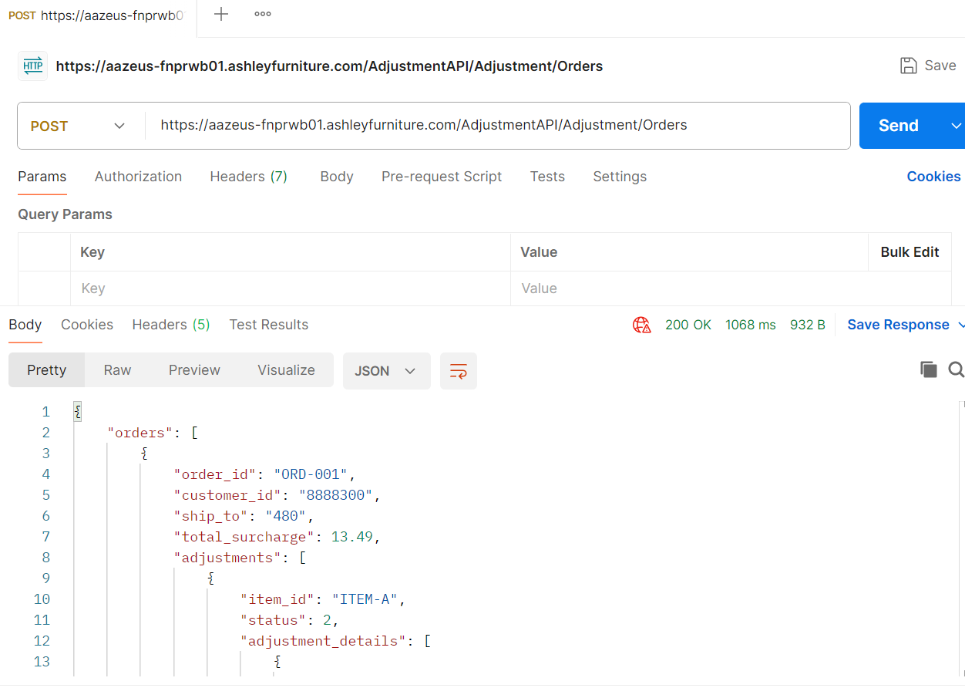

Call Output:
{
"orders": [
{
"order_id": "ORD-001",
"customer_id": "8888300",
"ship_to": "480",
"total_surcharge": 13.49,
"adjustments": [
{
"item_id": "ITEM-A",
"quantity": 2,
“price”:
"status": “2”,
"adjustment_details": [
{
“credit_code”:”IMP”
"adjustment_name": "IMP IMPORT SURCHARGE",
"adjustment_amount": 5,
"invoice_level": “1”,
"taxable": “N”,
"commissionable": “N”,
"calculation_value": 1,
"calculation_type": "PERCENT",
"applied_level": "ITEMCLASS",
"applied_level_value": "CLASS-A",
"charge": true
}
]
},
{
"item_id": "ITEM-B",
"quantity": 2,
“price”:
"status": “2”,
"adjustment_details": [
{
“credit_code”:”IMP”
"adjustment_name": "IMP IMPORT SURCHARGE",
"adjustment_amount": 8.49,
"invoice_level": “1”,
"taxable": “N”,
"commissionable": “N”,
"calculation_value": 1,
"calculation_type": "PERCENT",
"applied_level": "ITEMCLASS",
"applied_level_value": "CLASS-A",
"charge": true
}
]
}
]
}
]
}

In Process:
Below is the link for the common procedure documentation for calling the microservice from the AS400.

Common Procedure information for AS400 call of Pricing Adjustment Microservice (1).docx

Version

12/04/24 - Bill Collins Added price to the Output in the definition and the examples, moved the quantity field from the Adjustments Detail level to the Adjustments level.

